**Online Food Delivery CRM Project**

**Problem Statement:**

The food delivery industry handles thousands of daily orders from websites, apps, and partner channels. Without a centralized CRM, restaurants struggle to manage orders, assign deliveries, track status, and handle customer complaints. Delivery agents rely on manual updates, managers lack visibility, and executives don’t get real-time insights.

A **Salesforce-based Online Food Delivery CRM** is needed to:

* Automate order capture and assignment
* Enable real-time delivery tracking
* Centralize customer feedback and complaints
* Help managers monitor operations
* Provide executives with performance dashboards

**Phase 1: Problem Understanding & Industry Analysis**

**Requirement Gathering**

* Talk to stakeholders (restaurant managers, delivery agents, executives, customers).
* **Example requirements:**  
  - Track all restaurants and their menu items.  
  - Allow managers to assign orders to delivery agents.  
  - Prevent delivery conflicts (no double assignment).  
  - Capture customer complaints/feedback.  
  - Generate sales and delivery performance reports.

**Stakeholder Analysis**

* **Restaurant Managers** → Manage restaurants, menu items, orders, and customer complaints.
* **Delivery Agents** → Update delivery status, ensure timely order completion.
* **Executives / Management** → View performance dashboards, monitor KPIs.
* **System Administrator (CEO)** → Configure Salesforce org, oversee security and data integrity.

**Business Process Mapping**

* **Order Placement** → Customer places order → System captures order → Assigned to Restaurant Manager.
* **Delivery Assignment** → Restaurant Manager assigns order to Delivery Agent.
* **Delivery Update** → Delivery Agent updates status (Assigned → Out for Delivery → Delivered).
* **Feedback Handling** → Complaints/feedback logged and monitored by Manager.
* **Reporting** → Executives analyze performance metrics via dashboards.

**Industry-Specific Use Case Analysis**

* Real-time order tracking similar to Swiggy/Zomato.
* Menu & restaurant management within CRM.
* Delivery agent assignment and status updates.
* Customer complaints handling for service improvement.
* Performance dashboards for management review.

**AppExchange Exploration**

* Explore AppExchange packages:
* Food Delivery Management Apps for reference.
* Maps & Route Optimization apps for delivery tracking.
* SMS/Email Notification apps for customer communication.

......................................................................................................................................................

**Phase 2: Org Setup & Configuration**

**Salesforce Editions**

* Using Salesforce Developer Edition Org (free, permanent).
* Supports custom objects, flows, Apex, and dashboards.

**Company Profile Setup**

* Setup → Company Information → Edit.
* **Company Name:** Online Food Delivery CRM
* **Default Locale:** English (India)
* **Time Zone:** Asia/Kolkata (IST)
* **Currency:** INR
* Saved changes for org-wide consistency.

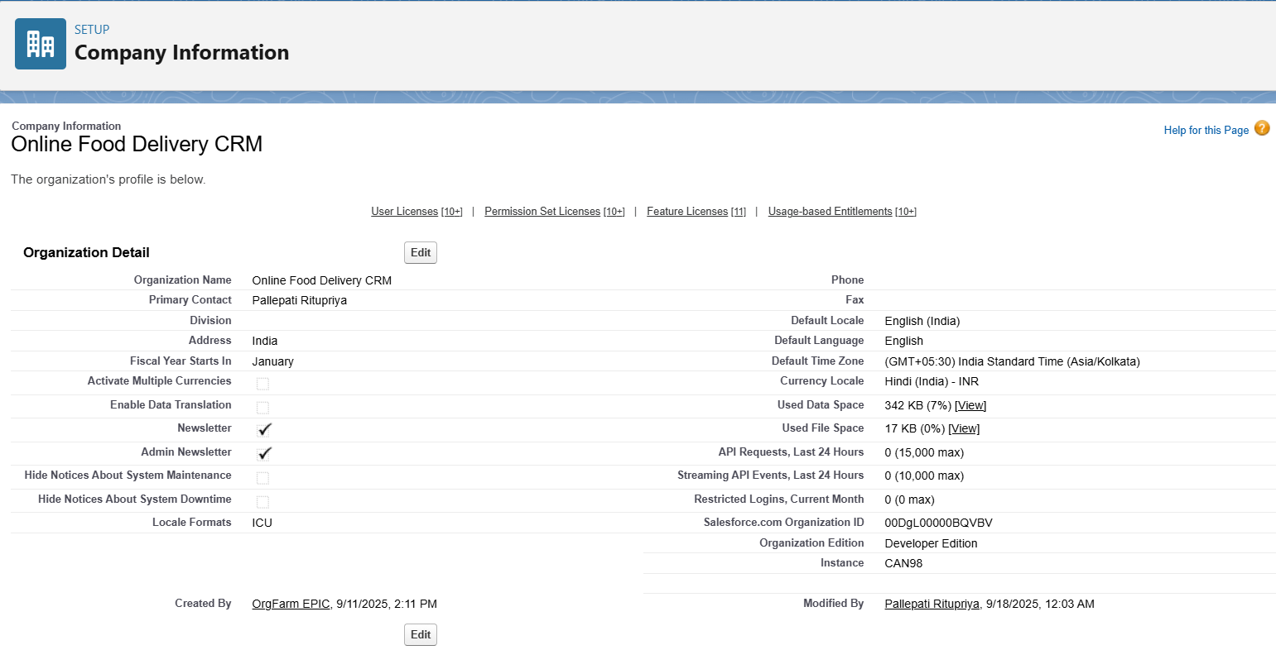

**Business Hours & Holidays**

* Setup → Business Hours → New Business Hours.
* **Working Hours:** 9:00 AM – 6:00 PM (Mon–Sat).
* Setup → Holidays → Add national holidays (e.g., 15th August – Independence Day).
* Ensures workflows/approvals don’t trigger during holidays.

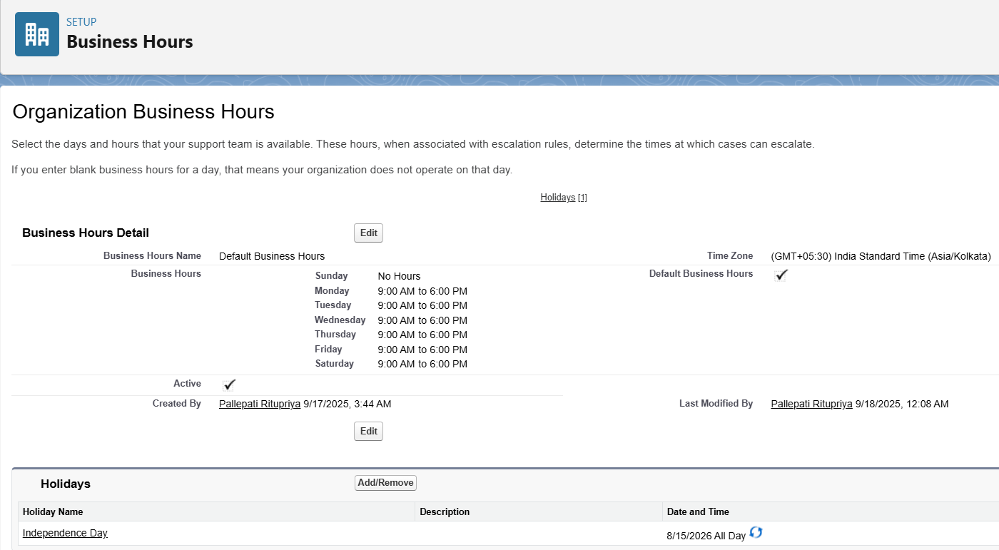

**Fiscal Year Settings**

* Setup → Fiscal Year → Standard (Jan–Dec).
* Useful for revenue and sales reporting.

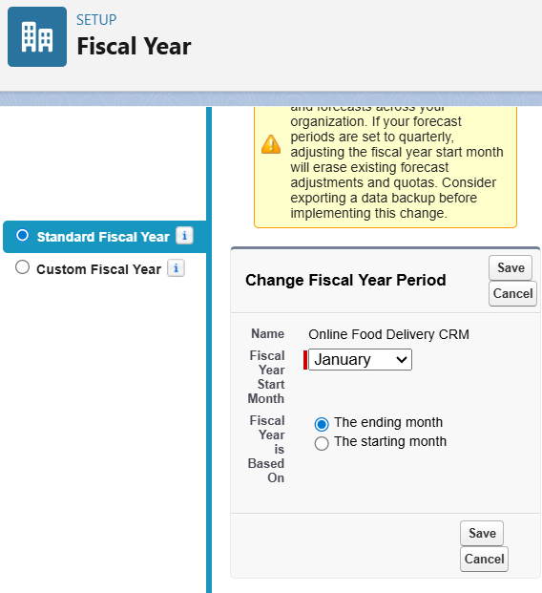

**User Setup & Licenses**

Created project-specific users:

* Me (Pallepati Ritupriya) = System Administrator (CEO) → Full access
* Anita Sharma (Restaurant Manager) → Salesforce License
* Ravi Kumar (Delivery Agent) → Salesforce License
* Priya Verma (Executive/Management) → Salesforce Platform License

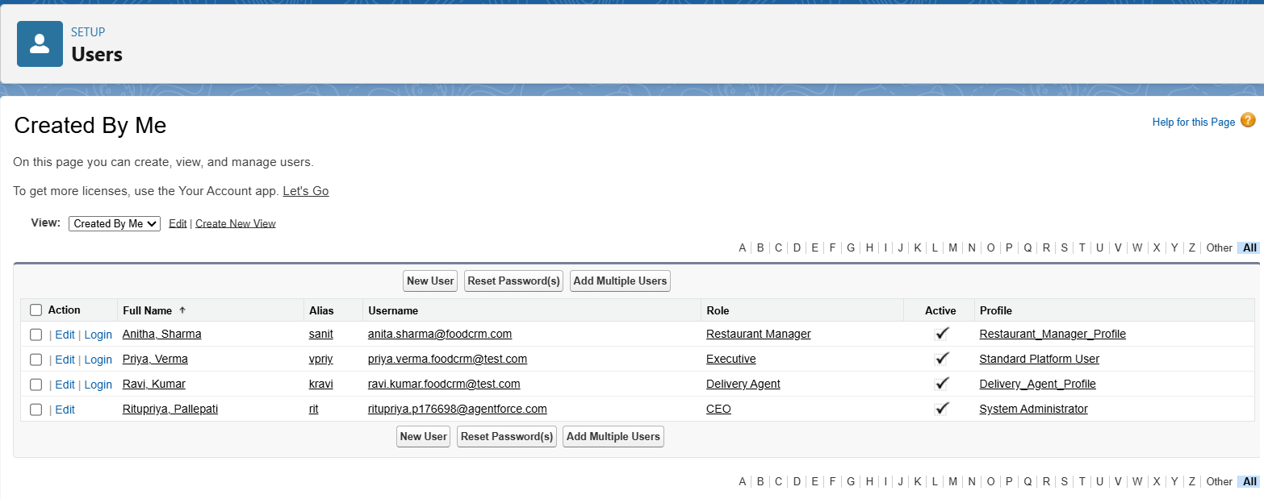

**Profiles**

* Cloned **Standard User** into custom profiles:
* Restaurant_Manager_Profile
* Delivery_Agent_Profile
* Executive_Profile

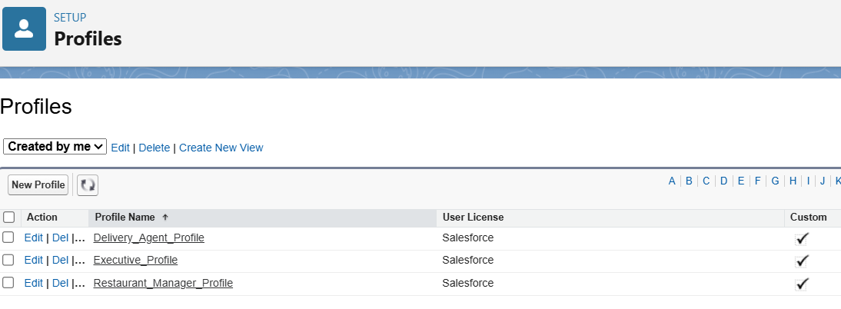

**Roles**

* **CEO (System Admin)** → Top-level, full access to all records.
* **Executive / Management** → Reports to CEO, sees all managers & agents records.
* **Restaurant Manager** → Reports to Executive, manages restaurants, menus, orders, and complaints.
* **Delivery Agent** → Reports to Manager, sees and updates only their assigned orders/deliveries.

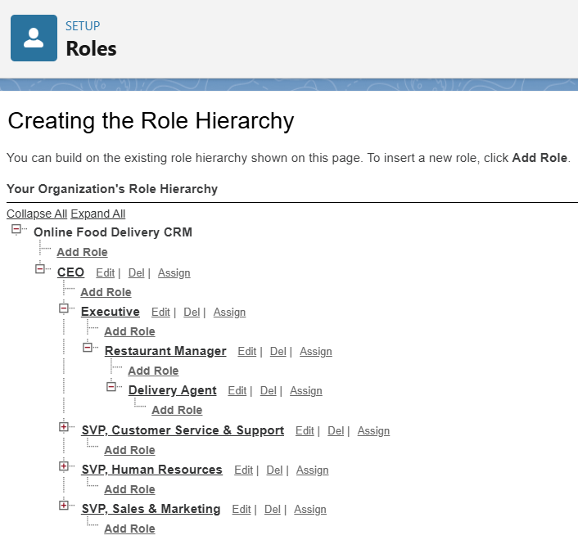

**Permission Sets**

Permission sets provide extra access without changing user profiles.

* **Reports & Dashboards Access** → Grants executives (Priya Verma) ability to run reports and view dashboards.
* **Complaint Manager Access** → Allows delivery agents (Ravi Kumar) to read/edit customer complaints when needed.
* **Delivery Assignment Access** → Gives restaurant managers (Anita Sharma) permission to reassign or update deliveries.

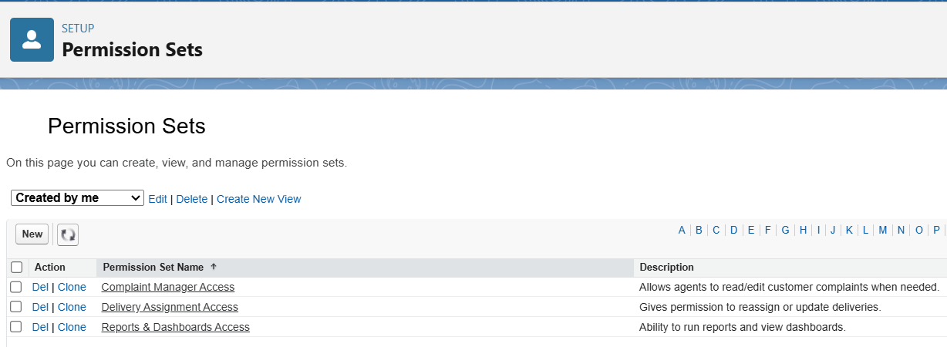

**Login Access Policies**

* Setup → Login Access Policies.
* Enabled Administrators Can Log in as Any User.
* Allows Admin to test features as Manager, Agent, or Executive.

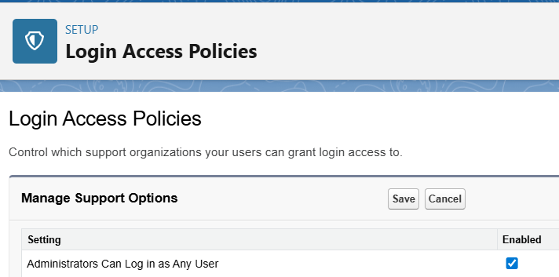

**Deployment Basics**

* Development in VS Code + Salesforce CLI.
* Metadata synced via package.xml.
* Source code stored in GitHub repo.
* **Deployment flow:**  
  VS Code (local changes) → Push to Salesforce Org → Commit to GitHub.